1. **Google Earth Pro Installation**

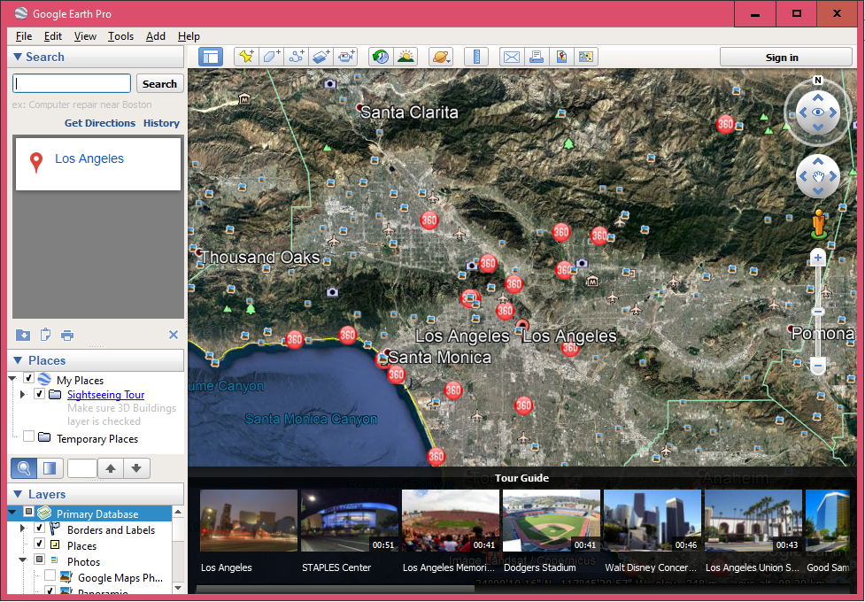

1. **Locations On GoogleEarth:**

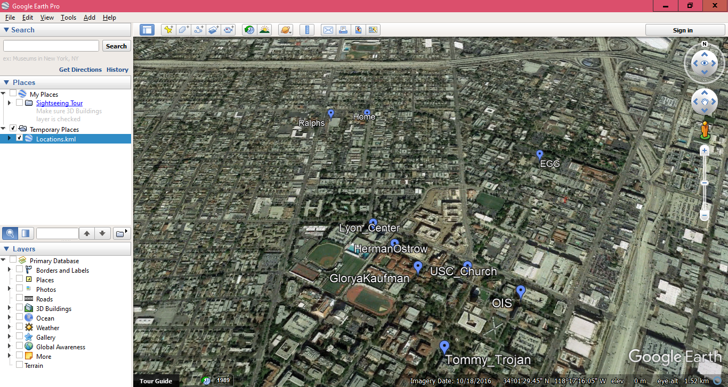

1. **Table Places Description:**

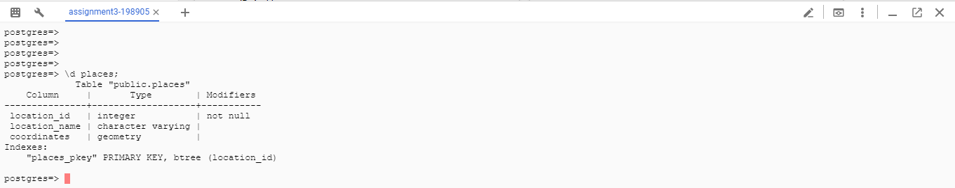

1. **Table Contents:**

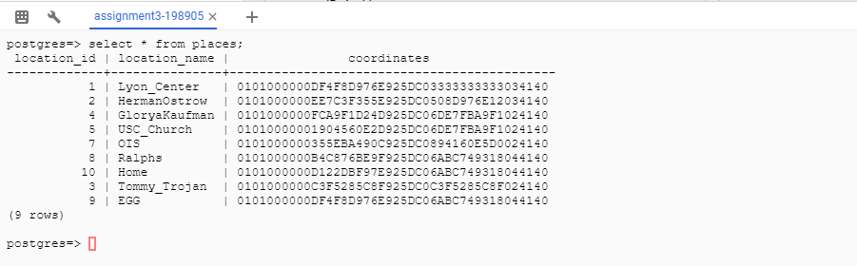

1. **Location+ConvexHull+K-nearest**

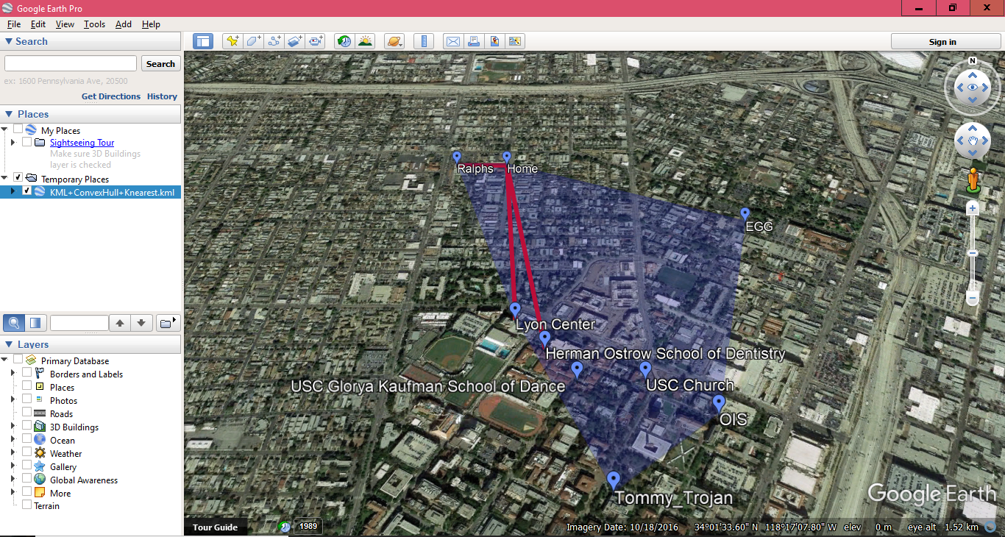

1. **Locations+ConvexHull**

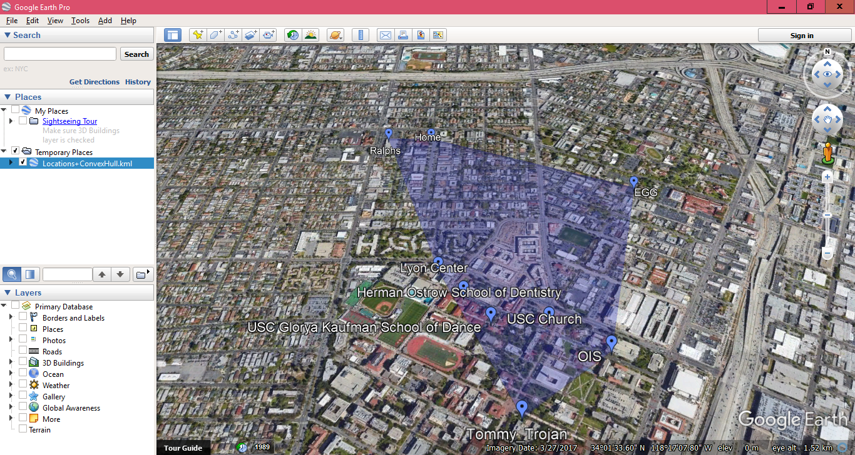

1. **Locations+Knearest**

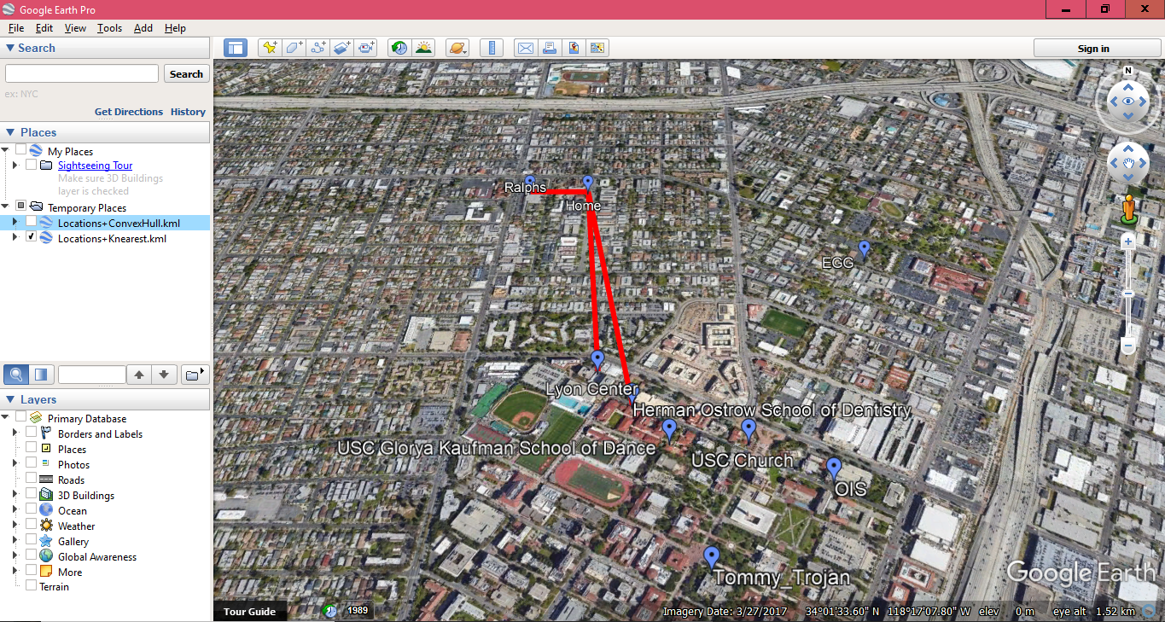

1. **Spirograph**

